Child Care Licensing
Program Director and Caregiver Training - Mecosta-Osceola ISD
August 27, 2019
10-2 (Miller Wing—MOISD)
Agenda

10:00-12:00 General provisions of Child Day Care Licensing power point and discussion
12:00-12:30 Lunch (provided)
12:30-1:30 Top violations cited at child care centers in Michigan
1:30-2:00 Mandated reporting requirements and procedures

Bring your questions! Now is the time to ask about field trips, sign-in sheets, emergency cards, releasing children, food service, napping, ratios (bathroom breaks, nursing breaks, etc.)

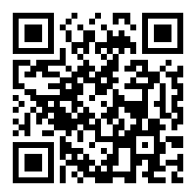
Register at: https://tinyurl.com/ChildCareLARA

Presenter: Don Vita, Child Care Licensing Consultant, State of Michigan Department of Licensing and Regulatory Affairs, Bureau of Community and Health Systems. Vitad1@michigan.gov

